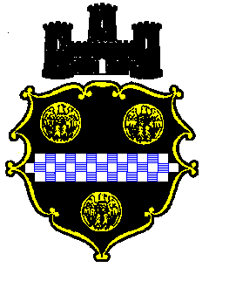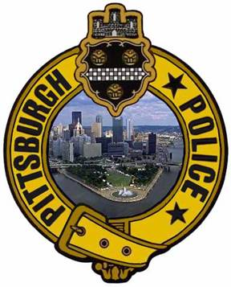

PITTSBURGH’S STUDENT POLICE ACADEMY

REGISTRATION DEADLINE EXTENDED!!!

The Pittsburgh Bureau of Police is offering a wonderful opportunity for students of the Allderdice High School community to become more closely acquainted with the roles and responsibilities of the Pittsburgh Police Bureau. The Pittsburgh Student Police Academy (SPA) brings the police and the schools youth close together in a setting that offers a sample of police training to each student.
Students receive three hours of training once a week for 15 weeks in many of the varied functions of law enforcement. They experience some of the highlights of police training and are exposed to the operations of the police bureau.
Participants are taught the basics of criminal law, search and seizure, patrol tactics, firearm safety and many other subjects. They learn about the processing of a crime scene, how police canines are used, and are exposed to many of the specialty police units. SPA participants meet and talk with many of the street officers as well as the command staff and training staff that serves them. All this takes place in a safe and entertaining training environment.
Instructors are law enforcement professionals who teach both veteran and recruit police officers. Students will leave this training with a greater understanding of the police mission and with an increased ability to see how the police serve the community.
This program is not an accredited certification course to become a sworn police officer.
The next session of the CPA will begin on Tuesday, February 2, 2016, at the Pittsburgh Allderdice High School, 2409 Shady Avenue, Pittsburgh, PA 15217. The program will be held each Tuesday evening, from 3:00 p.m. to 5:30 p.m. for 15 weeks.

Class size is limited to 25 participants. All interested students must complete an application and process their application to the Main Office by Friday, January 28, 2016. The application is on the back side of this letter.
For more information on the City of Pittsburgh Citizen’s Police Academy, please contact Sergeant Eric Kroll at:
Pittsburgh Police Training Academy
1395 Washington Boulevard
Pittsburgh, PA 15206
(412)665-3600
eric.kroll@pittsburghpa.gov

